**Final Project**



Max Sazhaev and Joshua Korovesi

**Table of Contents:**

Page 1: Title and logo

Page 2: Table of Contents

Page 3: Version history, Detailed Game Description, Controls, and Interface Sketch

Page 4: Screen Descriptions (Start State and Gameplay State)

Page 5: Screen Descriptions (Game-End State), Characters/Vehicles, Enemies, Scoring, and Sound Index

Page 6: Art / Multimedia Index (bullet image, grass image, tank mesh, bomb mesh, wrench mesh)

Page 7: All Assets Used

**Version History:**

Version 1 – December 2nd 2015

Version 2 – December 18th 2015

**Detailed Game Description:**

Level 1 – Get to the end of the training maze while picking up gas cans.

Level 2 - Get across the bridge of lava dodging zombies to get to the door on the other side.

Level 3 – Journey through the valley to get to the car, filling it up with gas and leaving this place.

**Controls:**

WASD – Forward, left, back, right.

Space – Jump.

Shift – Sprint.

**Interface Sketch:**

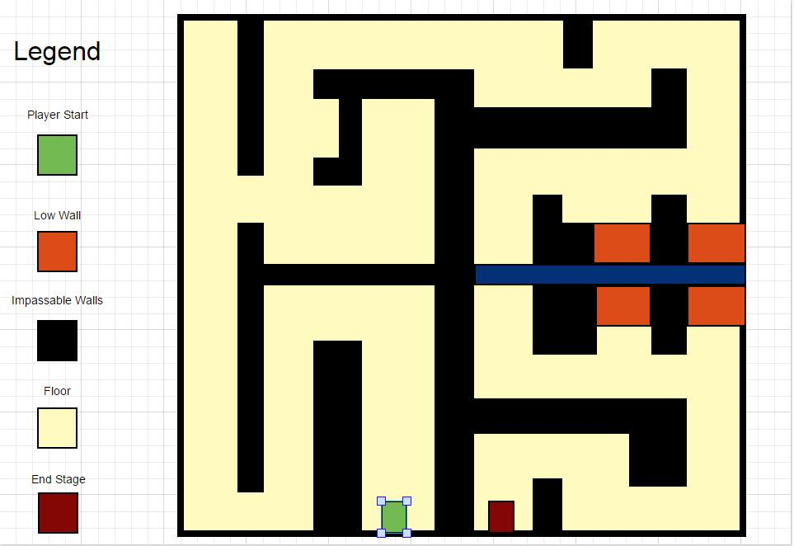

**Screen Descriptions:**

Start State:

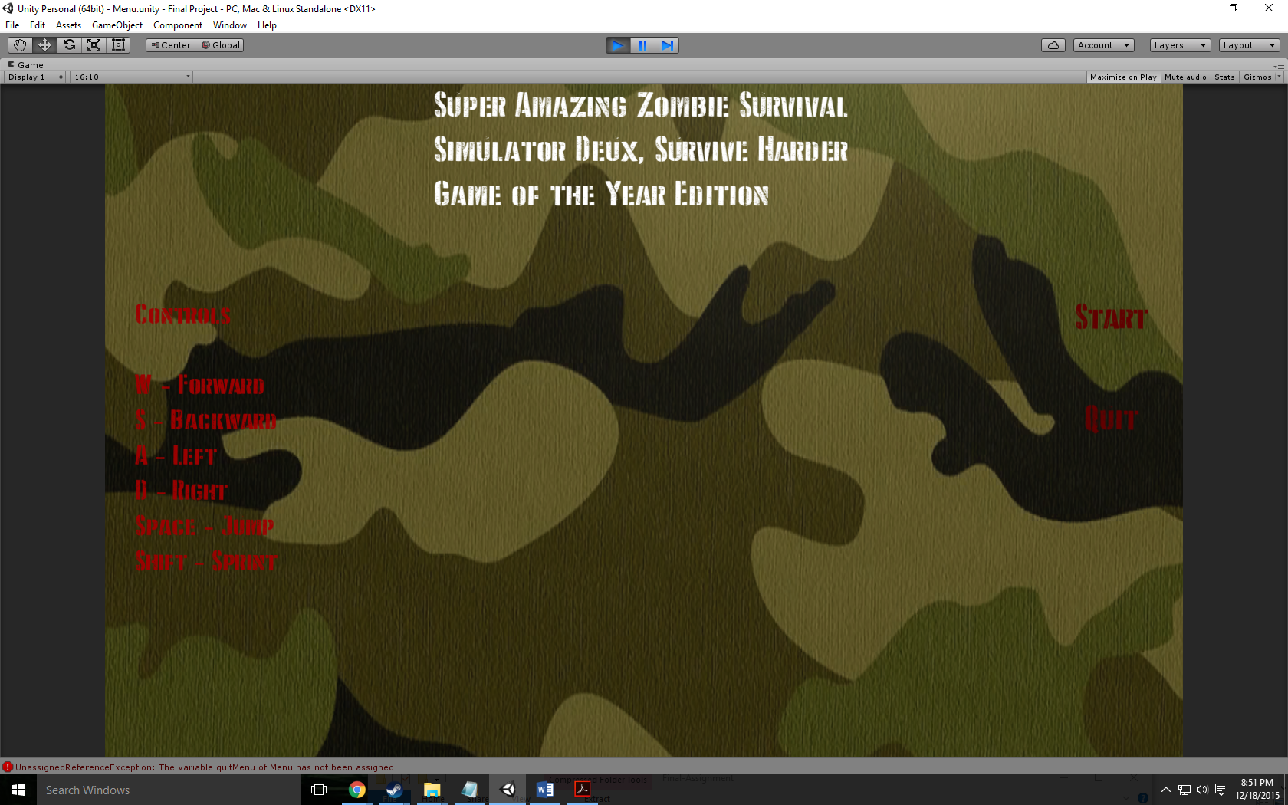

Death State:

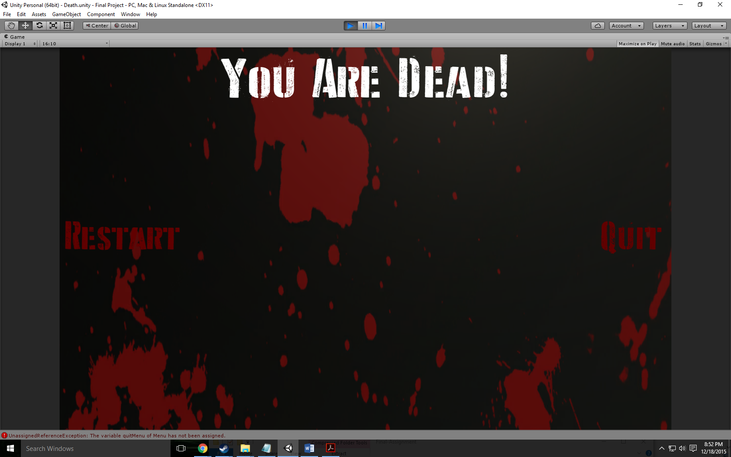

End State:

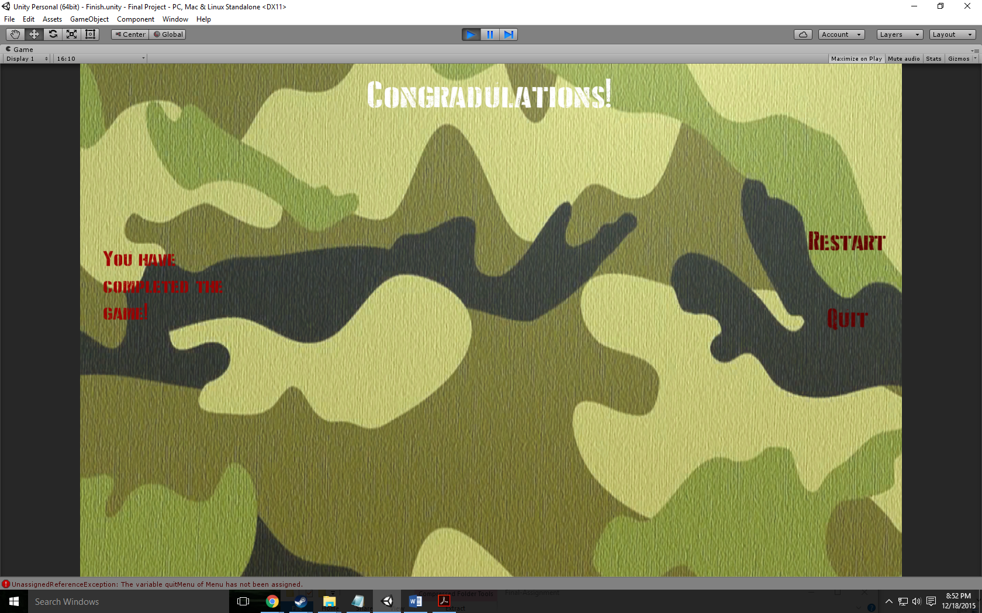

Level 1:

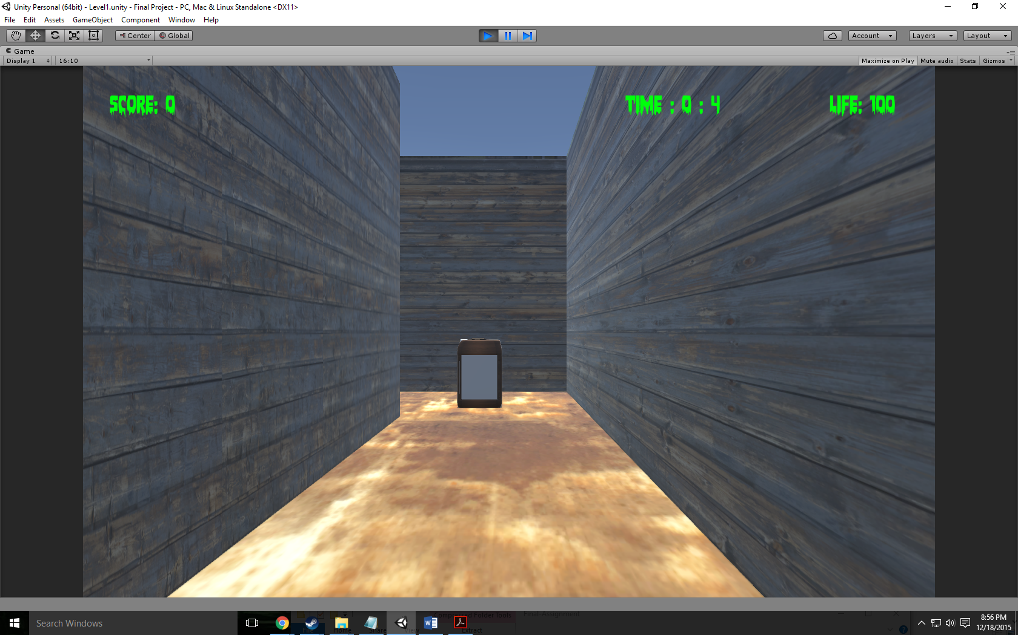

Level 2:

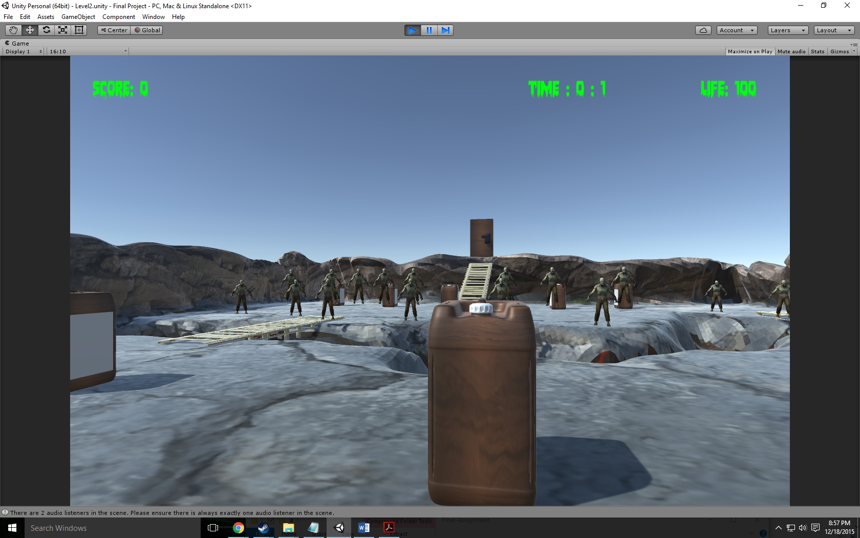

Level 3:

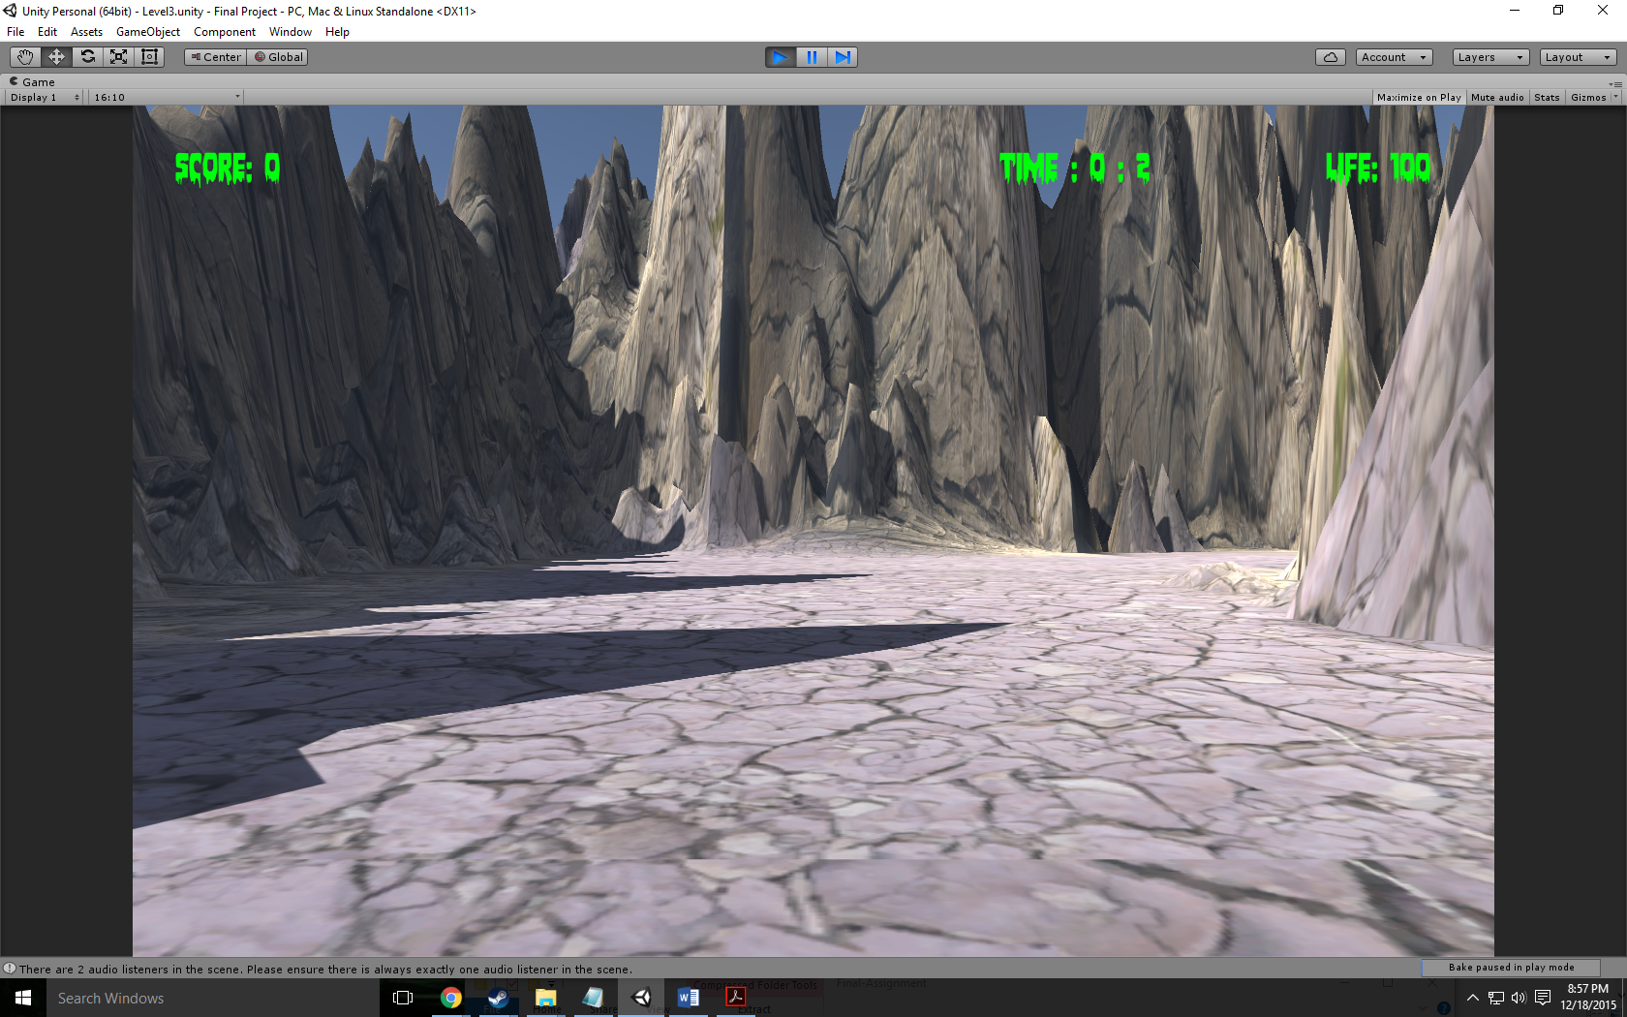

**Game World:**

Happy at first but then turns very dark and epic

**Levels:**

First level: Very happy training session

Second level: Gruesome being chased by zombies

Third level: Epic trying to get to the end destination (car) while being chased by zombies

**Characters / Vehicles:**

Player – moves forward, back, left, and right. Also jumps and sprints

**Enemies:**

Zombie follows with a simple script.

**Scoring:**

100 points per collected gas can on level 1 and 2

99999 points for single hidden collected gas can on level 3

**Sound Index:**

Footstep01 – Walking Sound

Jump – jump up sound

Land – Landing sound

Funeral Music – Death Scene

Life is strange main menu music – Menu Scene

Push it to the limit – First level

Master of puppets instrumental by Metallica – Second level

The Grand Cathedral from Serious Sam the 2nd Encounter – Third level

**Art / Multimedia Index:**

Rust Texture:



Water Texture:

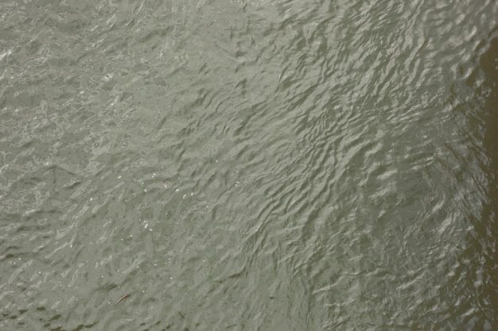

Wood Texture:



Main menu background:

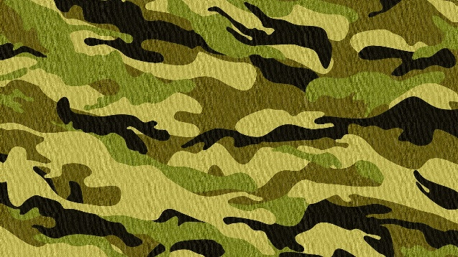

Death scene background:

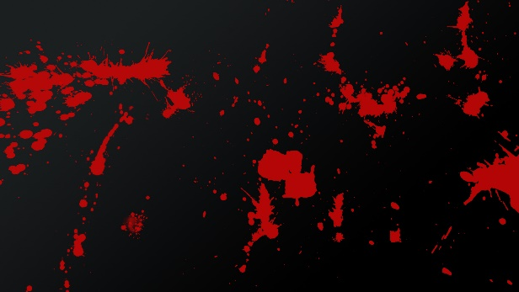

Car:

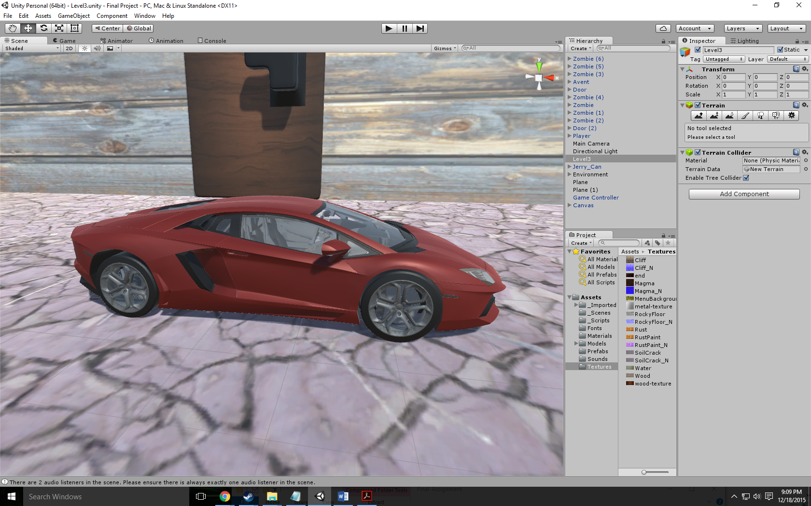

Door:

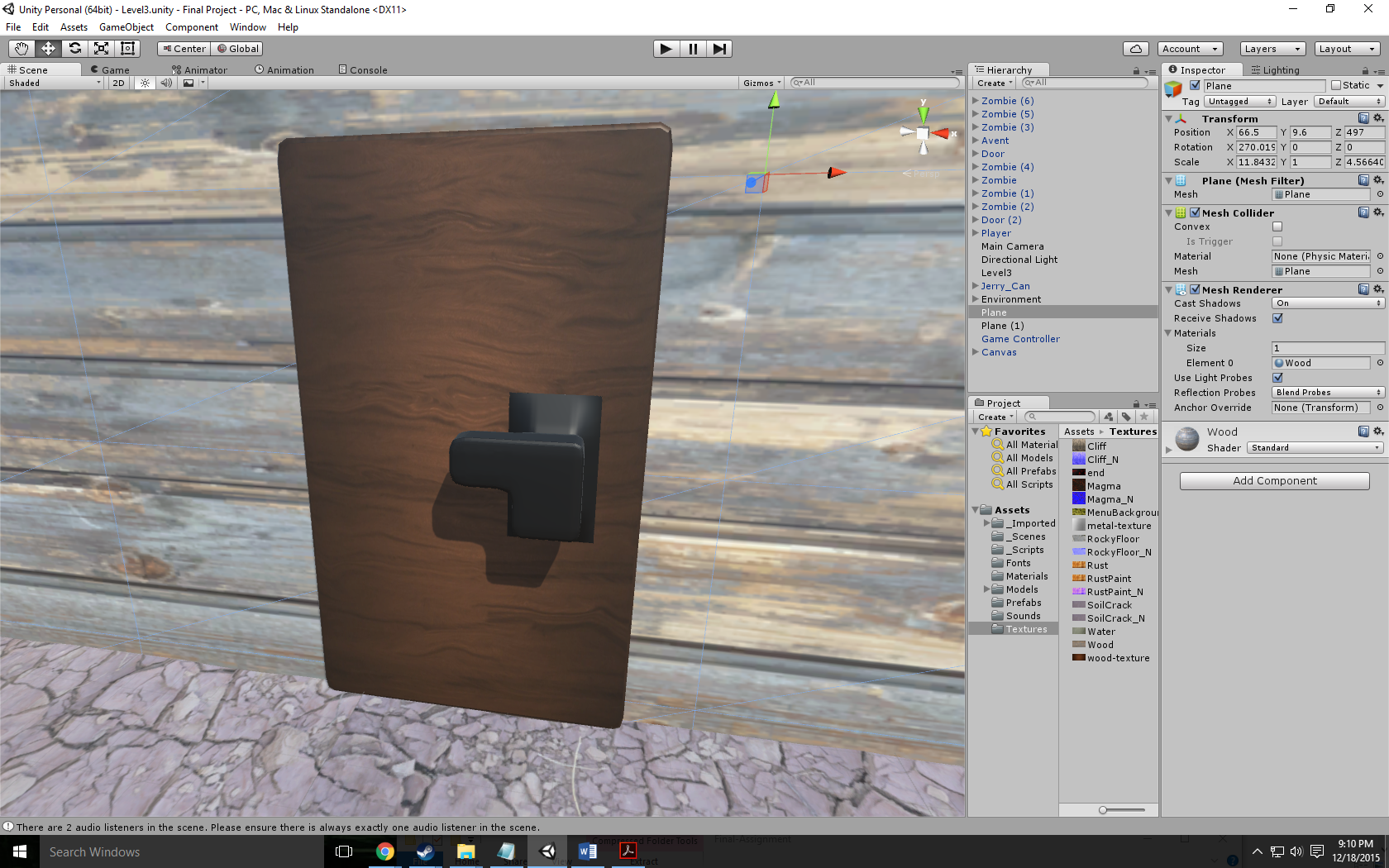

Gas Can:

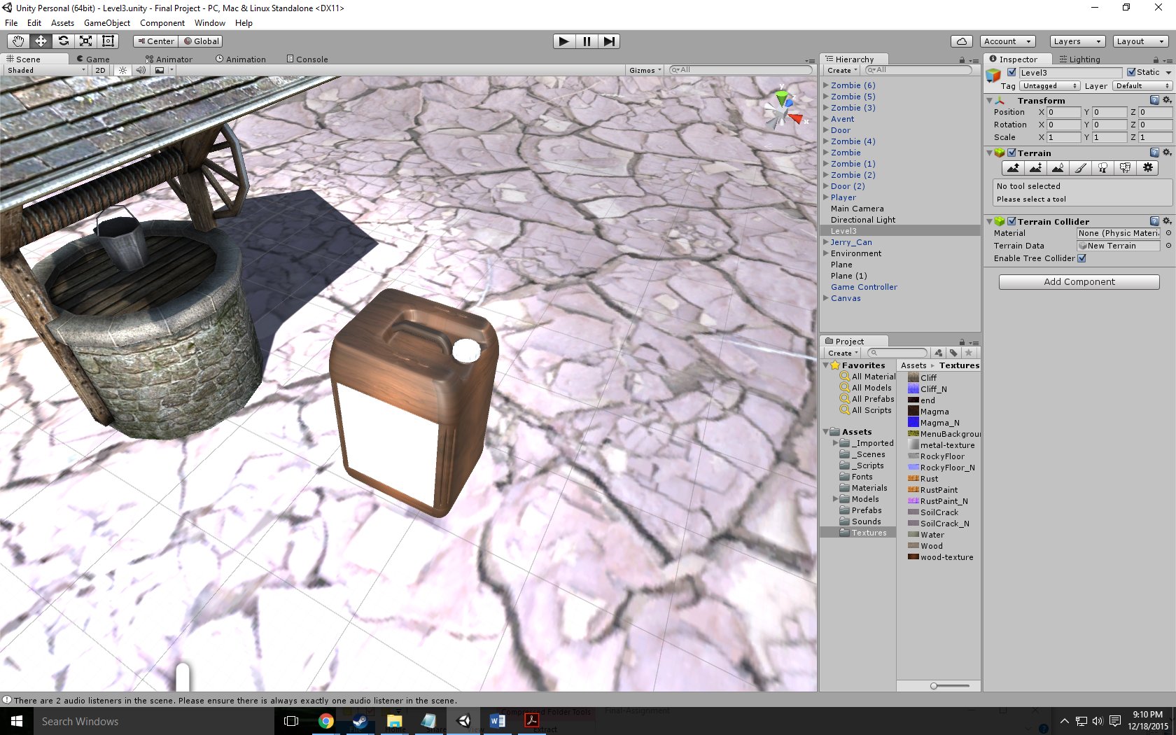

DDay font:

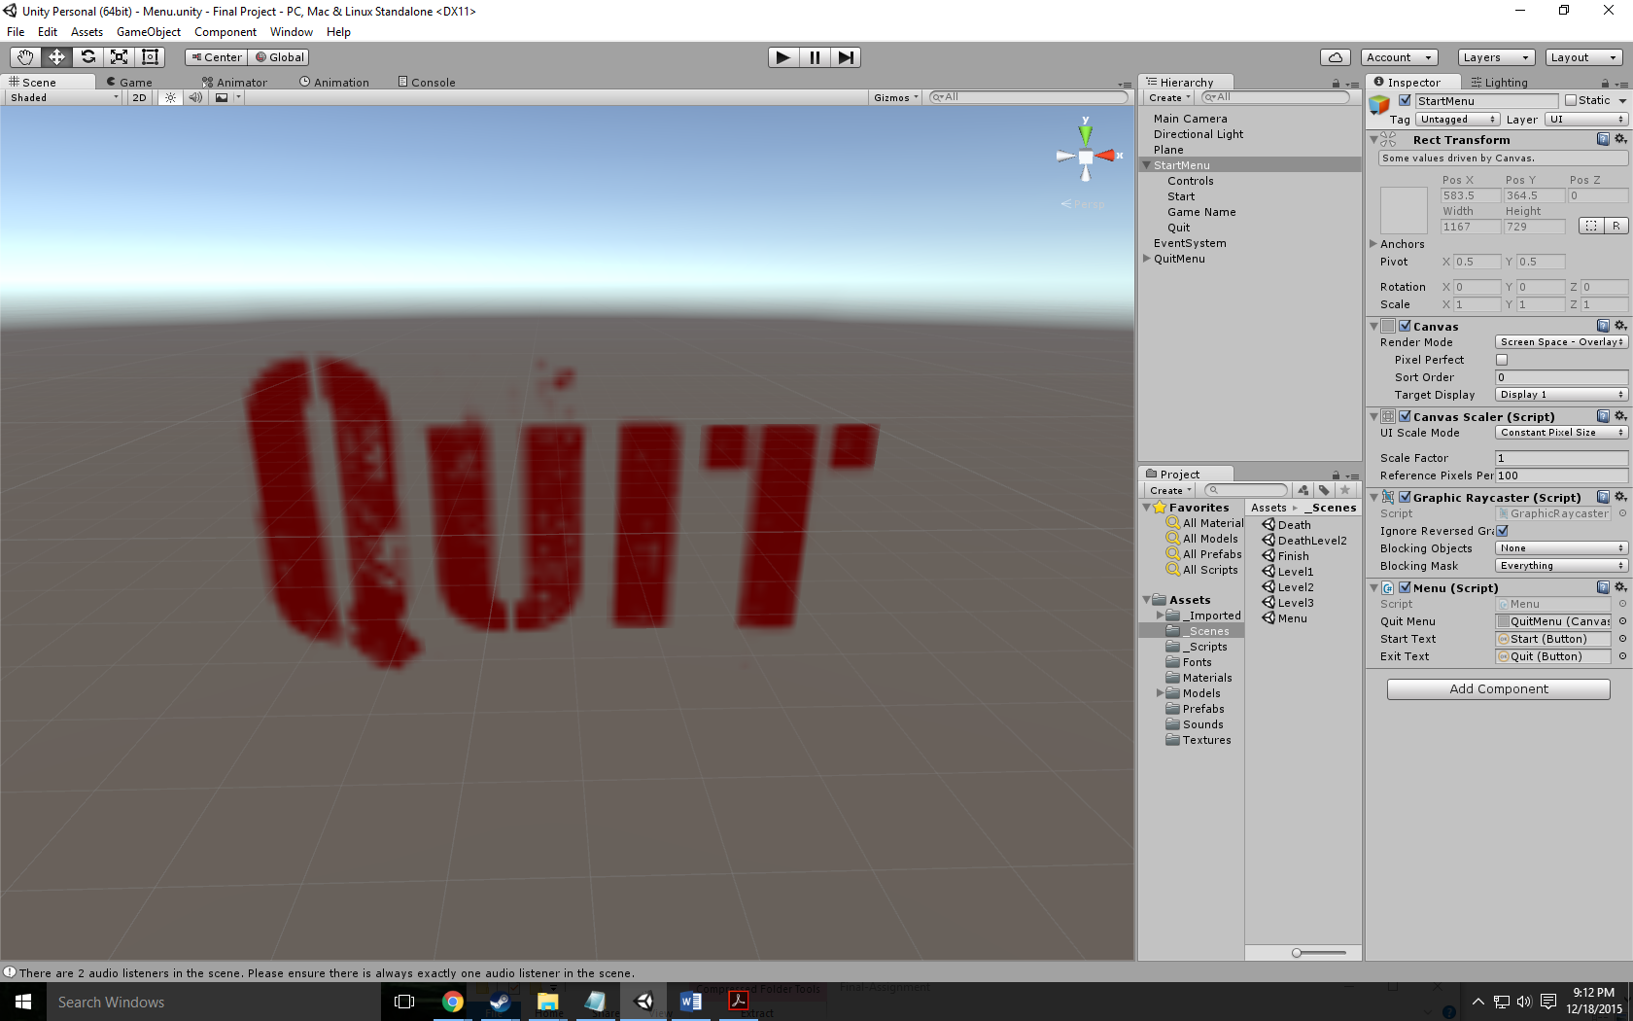

Bloodlust font:

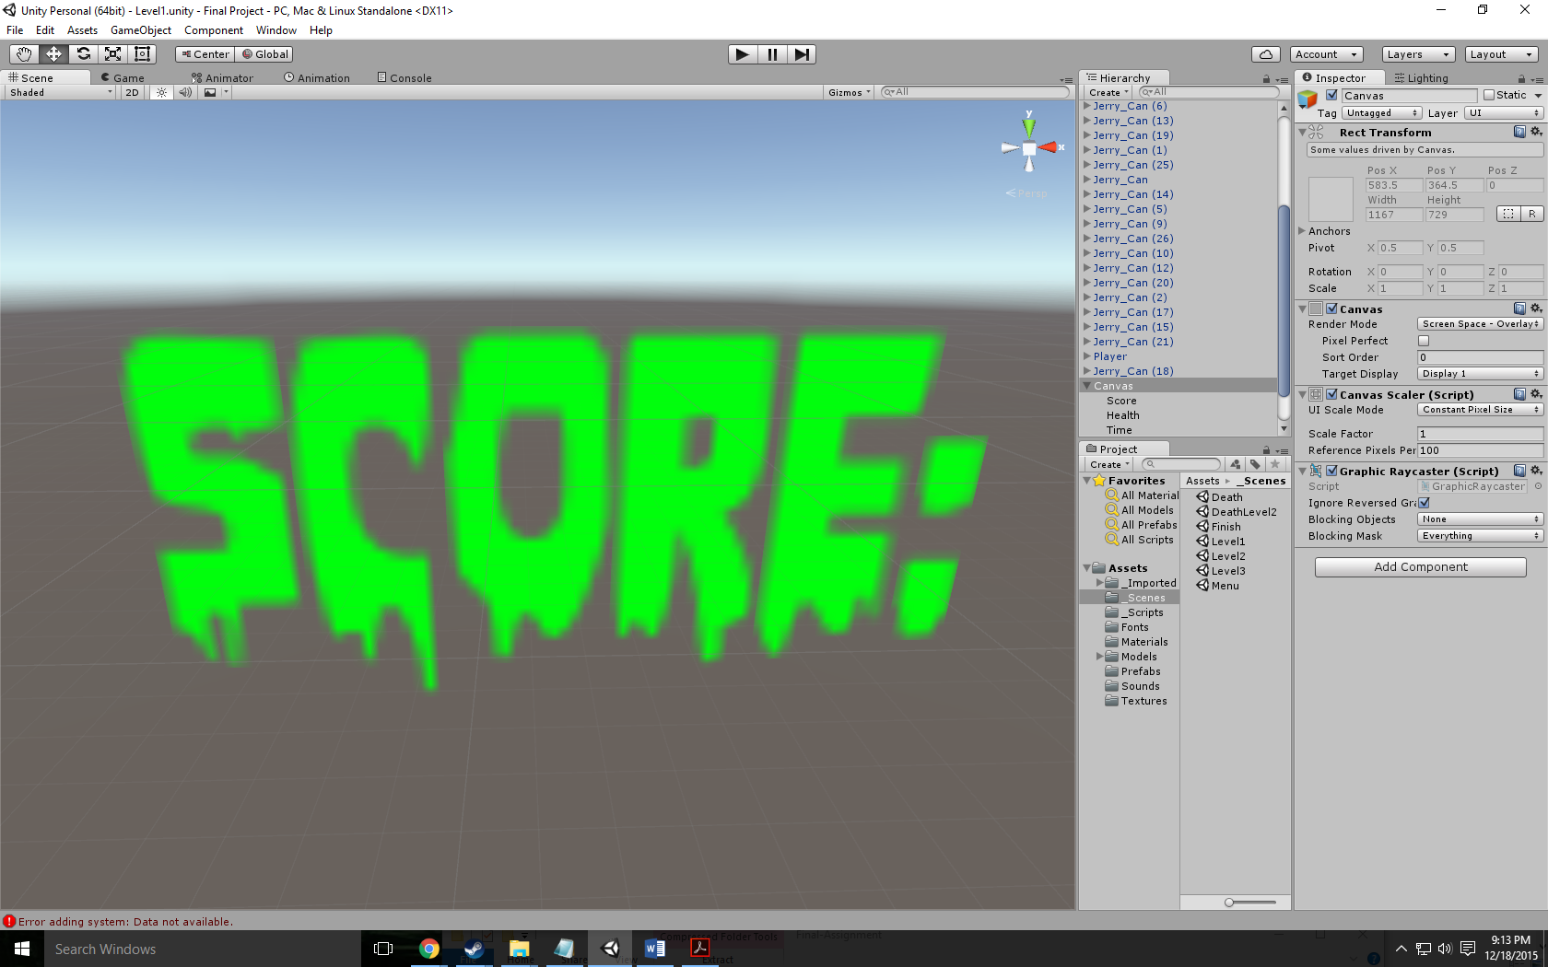

**All Assets Used:**

Wood Floors - <http://www.textures.com/download/woodplankspainted0191/66695>

Rusted Walls - <http://www.textures.com/download/rustpaint0170/31195>

Water Pit - <http://www.textures.com/download/waterplain0035/103458>

Door - <http://tf3dm.com/3d-model/modern-door-60753.html>

Menu Background - <http://wallpapercave.com/wp/9uIjAfm.jpg>

Death Background - <http://orig12.deviantart.net/db12/f/2012/038/5/0/blood_splatter_background_by_pudgey77-d4ozy89.jpg>

Level 1 Music - <https://www.youtube.com/watch?v=9D-QD_HIfjA>

Level 2 Music - <https://www.youtube.com/watch?v=_jYlloUKFmg>

Level 3 Music - <https://www.youtube.com/watch?v=0IVRoqDWwIk>

Menu Music - <https://www.youtube.com/watch?v=S3W0M8SVmk0>

Victory Music - <https://www.youtube.com/watch?v=5ppGs_t6014>

Death Music - <https://www.youtube.com/watch?v=SQ1nGH4VBEQ>

Gas Can - <http://tf3dm.com/download-page.php?url=cooking-oil-jerry-can-88575>

Car - <http://tf3dm.com/download-page.php?url=lamborghini-aventador-42591>

Bloodlust font - <http://www.1001freefonts.com/bloodlust.font>

DDay font - http://www.dafont.com/d-day-stencil.font